# EMERGING METHODS FOR EARLY DETECTION OF FOREST FIRE

**Domain : ARTIFICIAL INTELLIGINCE**

# Project Report Submitted by,

**Team ID : PNT2022TMID19246**

# Team LEADER :KARPAGATHARENI S

# Team Member 1:DHANUSHYA D

**Team Member 2:HEMAPRIYA N**

**Team Member 3:BHAVADHARANI S**

# TABLE OF CONTENTS

1. **INTRODUCTION**
   1. Project Overview
   2. Purpose
2. **LITERATURE SURVEY**
   1. Existing problem
   2. References
   3. Problem Statement Deﬁnition
3. **IDEATION & PROPOSED SOLUTION**
   1. Empathy Map Canvas
   2. Ideation & Brainstorming
   3. Proposed Solution
   4. Problem Solution ﬁt
4. **REQUIREMENT ANALYSIS**
   1. Functional requirement
   2. Non-Functional requirements
5. **PROJECT DESIGN**
   1. Data Flow Diagrams
   2. Solution & Technical Architecture 5.3 User Stories
6. **PROJECT PLANNING & SCHEDULING**
   1. Product backlog,Sprint Schedule and Estimation
   2. Project tracker,Velocity and Burndown chart
7. **CODING & SOLUTIONING (Explain the features added in the project along with code)**
   1. Server Side
   2. Client Side
   3. Schema
8. **TESTING**
   1. Acceptance Testing
   2. Test Cases Report
9. **RESULTS**
   1. Sample Screens
10. **ADVANTAGES & DISADVANTAGES**
    1. Advantages
    2. Disadvantages
11. **FUTURE SCOPE**
12. **REFERENCES**

# INTRODUCTION

## Project Overview

One of the most extremely occurring disasters in recent times is forest fires(wildfires). Due to these wildfires, a lot of acres of forest area are getting destroyed. The significant reasons that lead to the occurrence of forest fires are warming due to the increase in the average temperature of the earth and human negligence. Dynamic Integrated Model of Climate and the Economy (DICE) indicates that the economy will lose about $23 trillion in the next 80 years due to the change in climate . In Africa, South America, Southeast Asia, and New Zealand, forest fires occur due to human factors like husbandry of animals and agriculture . Nowadays, there are various technologies for fire modelling to predict the spread of fires, such as physical models and mathematical models . These models depend on data collection during forest fires, simulation, and lab experiments to specify and predict fire growth in many regions. Recently, simulation tools have been used to predict forest fires, but simulation tools faced some problems such as the accuracy of input data and simulation tool execution time .

## Purpose

Machine learning is a sub-branch of Artificial Intelligence (AI) to learn computers

aspect. Machine learning can be divided into two classes: supervised, unsupervised and reinforcement. In supervised learning, a supervisor is existed to give insights to the learning algorithm on how a decision or an action is bad or good. In supervised learning, the whole the data set is labelled completely. Supervised machine learning algorithms are as linear regression, Support Vector Machine (SVM), Artificial Neural Networks (ANN) and decision trees. In unsupervised learning, the data set is not labelled. This leads that the algorithm must define the labels. The structure of the data set and the relationship between the features will be learned by the algorithm. Unsupervised machine learning algorithms are as k-means clustering and Self-Organizing Map (SOM). In reinforcement learning, the learning algorithm gets punished in case of a wrong action and gets rewarded in case of correct action.

# LITERATURE SURVEY

## Existing Solutions

1. Deep convolutional neutral networks for forest fire detection Authors : Qingjie zhang,Jiaolong xu,Liang xu,Haiefeng guo

This paper proposes that forest fires can be

This paper proposes that forest fires can bedetected by vision-based fire detection systems whichcan be mounted to an unmanned aerial vehicle(UAVs) for strategically scanning acreage of fireprone areas. This paper also strongly recommendsConvolutional neural networks for identifying smokeand fire through videoframes which is taken a images. They have collected the dataset from differentinternet sources. They have resized the images tocanonical size of 240x320. In this paper, the basicidea is to find the fire patches in an image. Theauthors propose two methods for the algorithm tobuild the model. First was to apply fire patch classifierfrom scratch. Second was to teach a full imageclassifier and apply fine-tuned patch classifier if theimage contains fire. Then they compare SVM-pool5(Support vector machines) with CNN-pool5, theaccuracies recorded are 95.6% and 97.3% respectivelywith a detection rate of 84.8%, making CNN-pool5network more accurate than SVM-pool5 classifier

1. Fire dtection system using machine learning

Authors : AArul,R S Hari prakaash,RGokul raja,V

Nandhalai

Fire can be detected by using the amount ofsmoke. The smoke sensors are used to measure theamount of smoke from the fire, and it could becompared with a threshold value and if it is beyondthat value, it is considered as a fire scenario. Usingimage processing, fire can be detected as soon aspossible. Fixing the CCTV camera everywhere andthe images from these cameras can be processed tomonitor the fire. If any changes occur, it is easy todetect and extinguish the fire

quickly. This system hasa water extinguisher for extinguish the fire when thealarm turns on. The CCTV camera is used forrecording the video of a particular spot and it isconnected to a mini- computer called Raspberry-pi.So that it could get the constant video recording of aparticular area. The captured video pictures areprocessed frame by frame and once the fire detected,the alarm would be turn on. Also, the alarm would beturned off when the fire extinguished completely. TheVirtual Network Computing is used for the executionof the program, where the details of video aretransferred from the raspberry-pi to the viewingcomputer. This system includes detection, alert, fireextinguish, software and network modules

(c )A Forest fire detection system based on ensemble

learning

Authors : Renjie Xu, Haifeng Lin,Kangjie Lu,Lin Cao,Yunfei Liu

In this paper, a novel method for firedetection is proposed based on ensemble learning.The dataset is created using 10581 images fromvarious public sources like BowFire FD-Dataset, ForestryImages,VisFire.The dataset ispreprocessed and fed into not just one but twoindividual object detectors, YOLOv5 and EfficientDetintegrated in parallel mode to achieve better accuracythan a single object detector. Although it usesintegrated object detectors, this does not take thewhole image into consideration. Therefore, anotherclassifier is introduced to solve this problem.EfficientNet takes the image as wholeand evaluatesthe image to enable total advantage of theinformation. The results will be decided by a decisionstrategy algorithm which takes the opinion of the three individual object detectors into account which inturn improves the performance of the model and decrease the rate of False positives. This paper claims that they have achieved a superior trade-off average accuracy, average recall, false positive and latency

(d)Forest fire image recogntion based on convolution neural network

Authors : Yuanbin Wang,Langfei Dang,J.Ren

In fire detection, the color of the imagefrom a camera is highly important. Sometimes, it doesnot possible to watch the entire forest imagesaccording to the size as it may be some difficulties indetecting the fire. So that, using Convolutional NeuralNetwork (CNN) technology would be easier to avoidthe blindness and accurate level of fire identification.It uses the support vector mechanism for the imageclassification. In this technique, the image issegmented based on the color of the flame andtransferred to the CNN network. This would be foundout more attributes and decide there is a fire occurs or not. Fire can be detected by analyzing the color of the flame in a picture. Finding the fire by using thenumber of pixels plotted in a picture according to thefire color and can be measure the intensity of the fire.So that, it should be easier to detect fire and stamp outthe fire. The system should be trained and tested usinga large amount of data. Algorithms are used for thesegmentation of images and in finding the fire. Thismethod should be more effective and reliable inidentifying the fire. The accuracy should be much better than the other methods.

## Proposed Solution

The forest is a large surface of area filled with trees, lots of dried leaves, woods and so on.These elements encourage the fire when it starts.Thefire can be ignited through many reasons such as high temperature in summer seasons, smoking, or someparties which having fireworks. Once fire starts, itwill remain until it distinguished completely. The damage and the cost for distinguish fire because offorest fire can be reduced when the fire detected early as possible. So, the fire detection is important in thisscenario. Finding of the exact location of the fire andsending notification to the fire authorities soon after the occurrence of fire can make a positive impact.There are different types of fire detection methods used by the Government authorities such as satellitemonitoring, tower

monitoring, using sensors, optical cameras and so on. There are some other techniques used for fire suppression.they are using flying water tanks for fire suppression. In middle east countries, theseelements sweep away and burnt it in a certain unfuelled place.But, they provide fire inthese areas and wait until it dies itself without make any danger to the wildlife or humans.

# IDEATION & PROPOSED SOLUTION

## Empathy Map Canvas



* 1. **Ideation & Brainstorming**

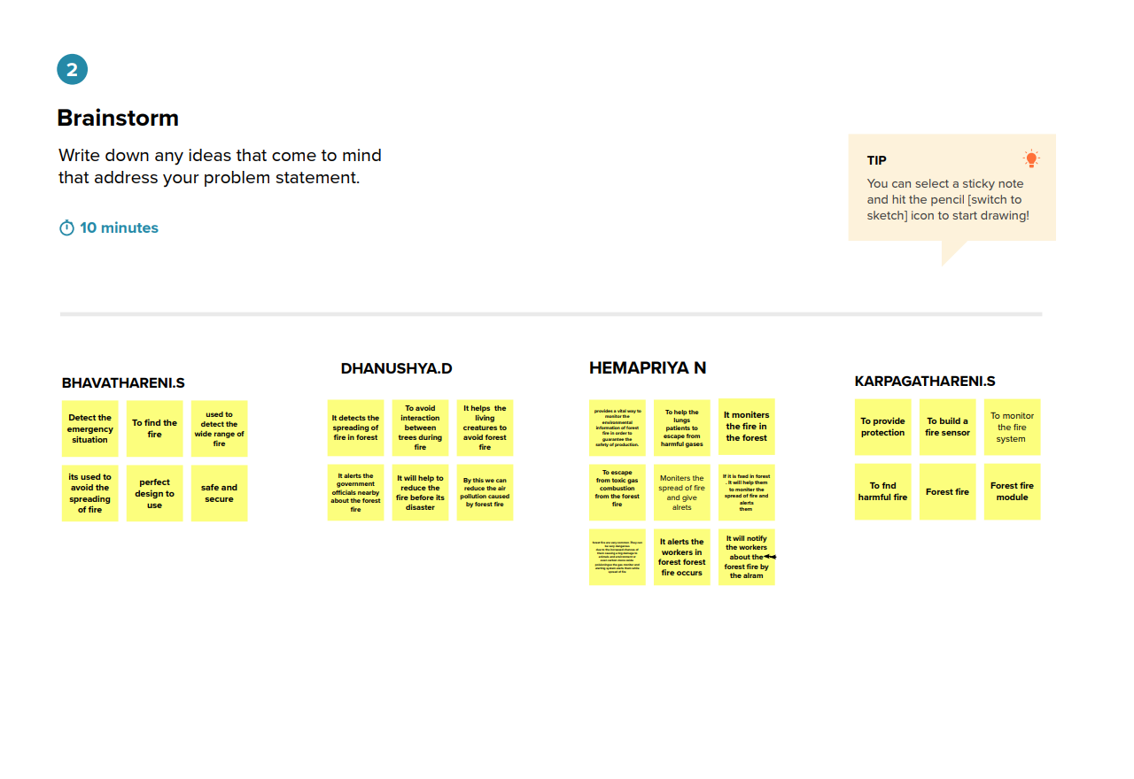

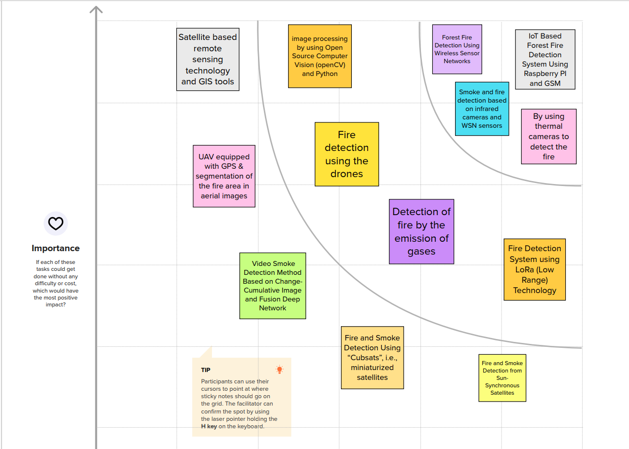

## Proposed Solution

The ability to predict fire progression and area burned is crucial to mitigating the immediate and far-reaching consequences of wildfires. Existing studies have attempted to fill this gap, mainly through mathematical models but predictive techniques would enable decision makers to deal

with large amount of data in a more timely manner. The Wildland Fire Management Research, Development & Application Organization proposed a wildland fire decision support tool called FSPro (Fire Spread Probability). FSPro is a geospatial probabilistic model that predicts fire growth, and is designed to support long-term decision making. FSPro addresses fire growth beyond the timeframes of reliable weather forecasts by using historic climatological data. FSPro calculates and maps the probability that fire will spread to areas on the landscape based on the current fire perimeter or ignition point.

we propose an intelligent system based on genetic programming for the

prediction of burned areas of forest fires. In order to build predictive models, we only considered data relating to forest characteristics and meteorological data. Drawing on the idea of using computational intelligence techniques

* 1. **Problem Solution Fit**

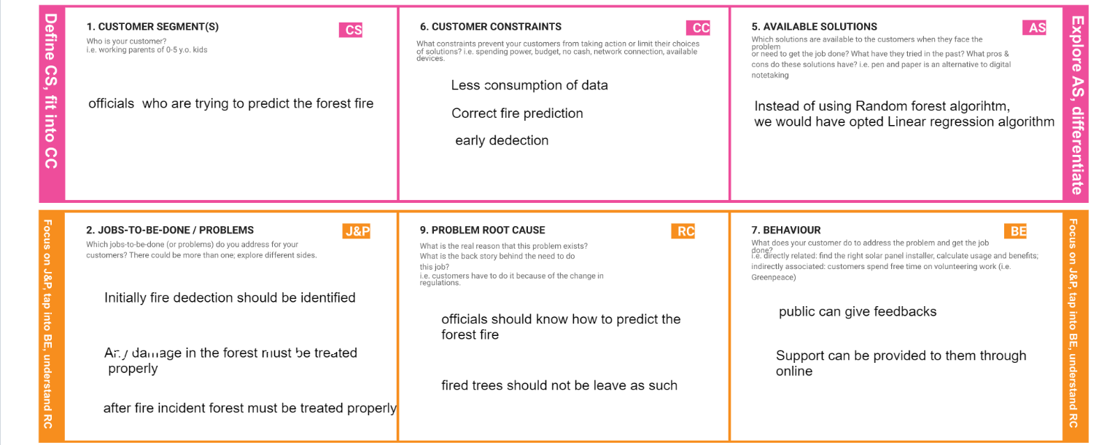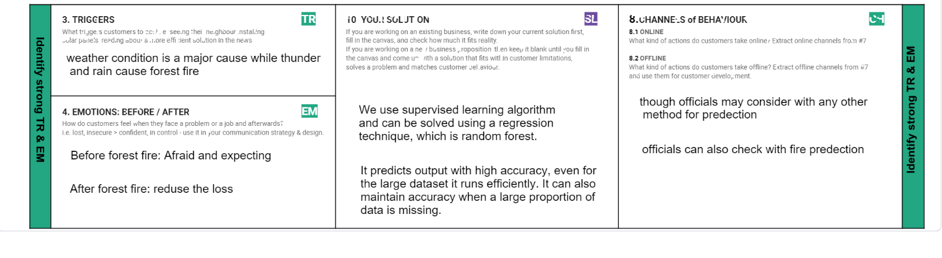

# REQUIREMENT ANALYSIS

## Functional Requirements

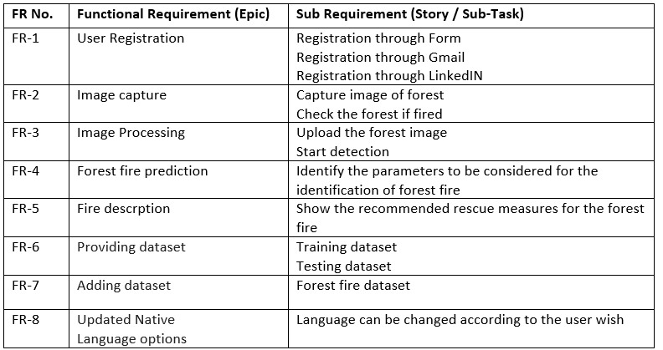

* 1. **Non-Functional Requirements**

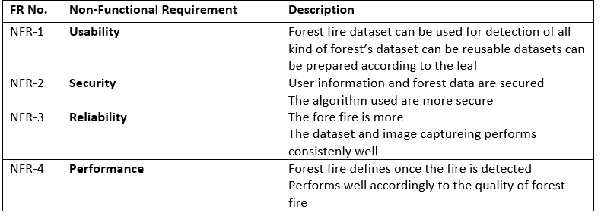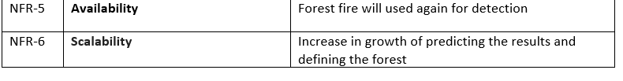

# PROJECT DESIGN

## Data Flow Diagrams

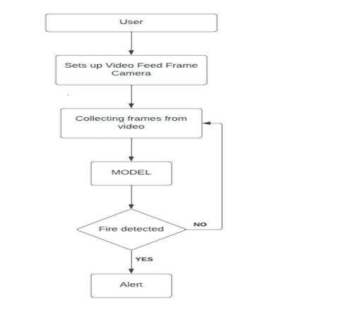

* 1. **Solution & Technical Architecture**

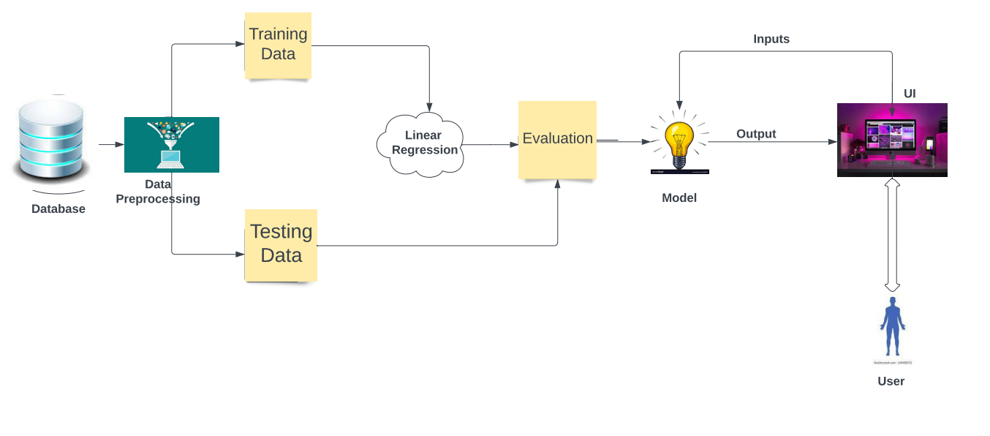

* 1. **User Stories**

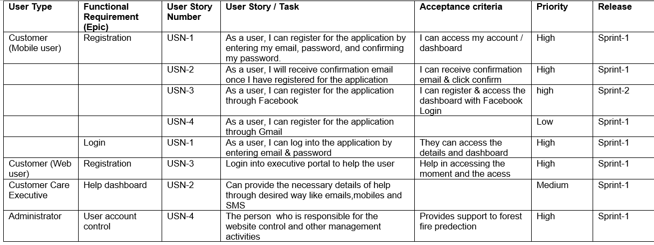

# PROJECT PLANNING AND SCHEDULING

## Product Backlog, Sprint Schedule, and Estimation

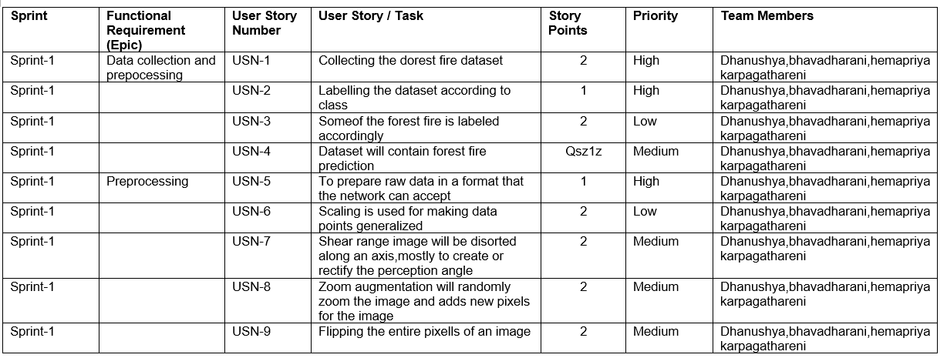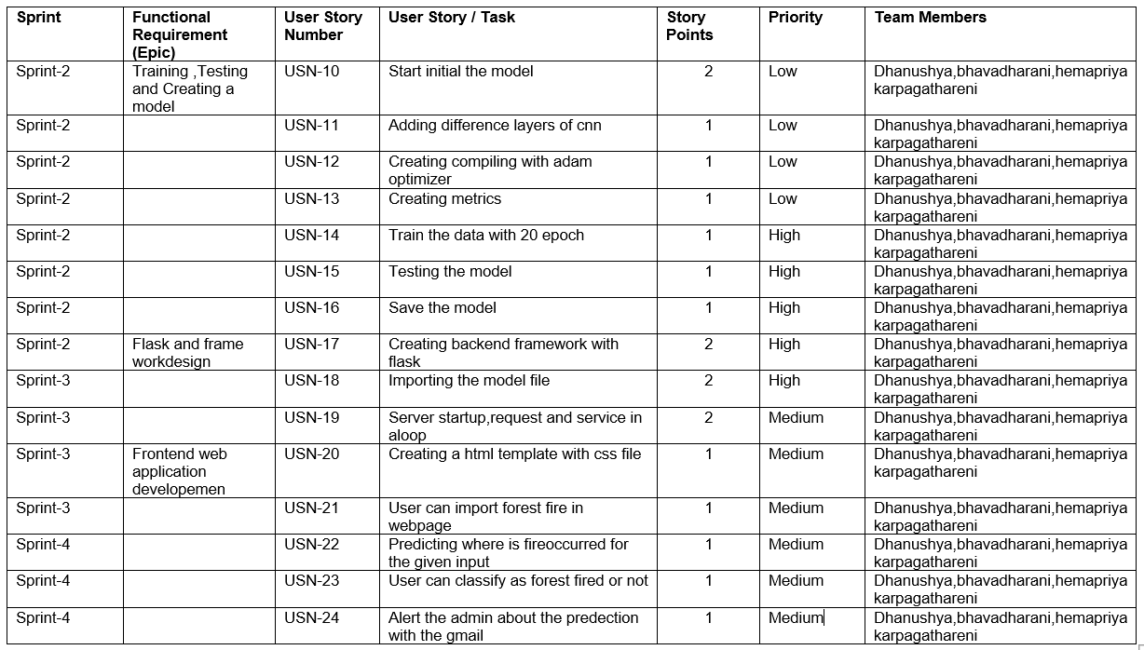

* 1. **Project Tracker, Velocity & Burndown Chart**

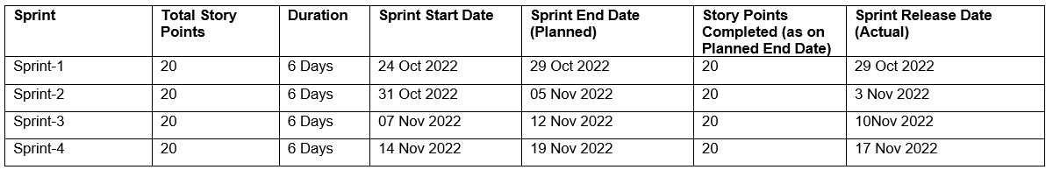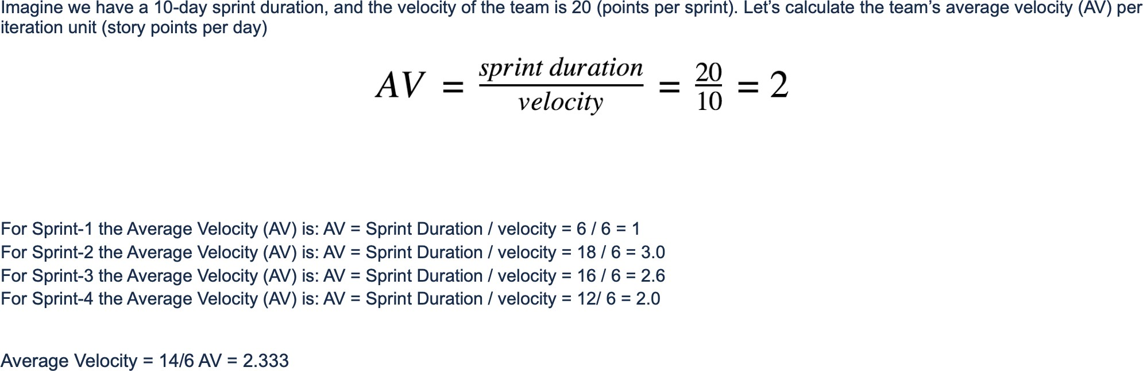

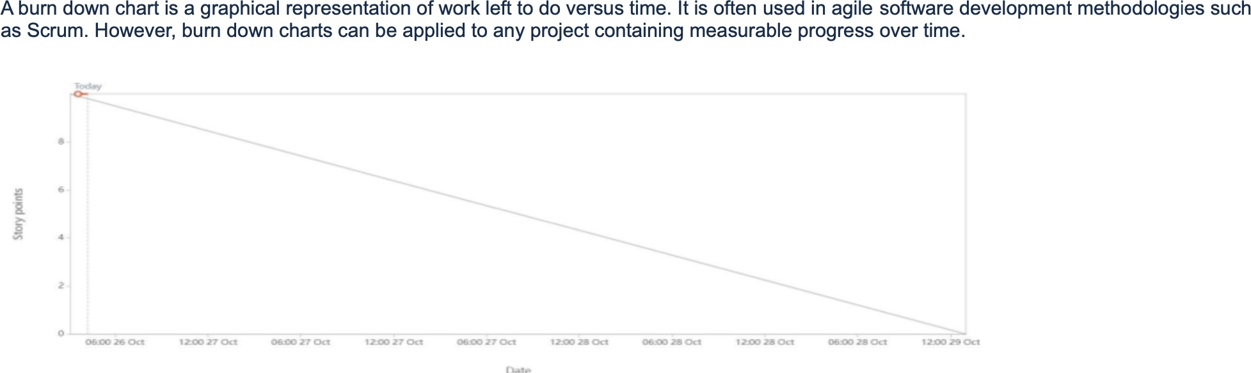

# CODING & SOLUTIONING

**7.1**

**import** pandas **as** pd

**import** numpy **as** np

**import** seaborn **as** sns

**import** matplotlib.pyplot **as** plt

**from** scipy.stats **import** norm

**from** sklearn.model_selection **import** train_test_split

**from** sklearn.linear_model **import** LinearRegression, Lasso, Ridge, ElasticNet

**from** sklearn.preprocessing **import** PolynomialFeatures, MinMaxScaler, LabelEncoder

**from** sklearn.svm **import** SVR

**from** sklearn.metrics **import** r2_score

**from** sklearn.metrics **import** mean_squared_error

**import** warnings; warnings**.**simplefilter('ignore')

*# Importing the dataset*

df_forest **=** pd**.**read_csv("/content/forestfires (1).csv")

df_forest**.**head()

print ("The shape of the dataset : ", df_forest**.**shape)

plt**.**rcParams['figure.figsize'] **=** [8, 8]

sns**.**distplot(df_forest['area']);

df_forest['u_area'] **=** np**.**log(df_forest['area'] **+** 1)

plt**.**rcParams['figure.figsize'] **=** [20, 10]

sns**.**set(style **=** "darkgrid", font_scale **=** 1.3)

month_temp **=** sns**.**barplot(x **=** 'month', y **=** 'temp', data **=** df_forest,

order **=** ['jan', 'feb', 'mar', 'apr', 'may', 'jun', 'jul', 'aug', 'sep', 'oct', 'nov', 'dec'], palette **=** 'winter');

month_temp**.**set(title **=** "Month Vs Temp Barplot", xlabel **=** "Months", ylabel **=** "Temperature");

df_forest**.**day**.**unique()

plt**.**rcParams['figure.figsize'] **=** [10, 10]

sns**.**set(style **=** 'whitegrid', font_scale **=** 1.3)

day **=** sns**.**countplot(df_forest['day'], order **=** ['sun' ,'mon', 'tue', 'wed', 'thu', 'fri', 'sat'], palette **=** 'spring')

day**.**set(title **=** 'Countplot for the days in the week', xlabel **=** 'Days', ylabel **=** 'Count');

plt**.**rcParams['figure.figsize'] **=** [8, 8]

sns**.**set(style **=** "white", font_scale **=** 1.3)

scat **=** sns**.**scatterplot(df_forest['temp'], df_forest['area'])

scat**.**set(title **=** "Scatter Plot of Area and Temperature", xlabel **=** "Temperature", ylabel **=** "Area");

plt**.**rcParams['figure.figsize'] **=** [8, 8]

sns**.**set(style **=** "white", font_scale **=** 1.3)

scat **=** sns**.**scatterplot(df_forest['temp'], df_forest['u_area'])

scat**.**set(title **=** "Scatter Plot of Area and Temperature", xlabel **=** "Temperature", ylabel **=** "Area");

plt**.**rcParams['figure.figsize'] **=** [20, 10]

sns**.**set(style **=** 'white', font_scale **=** 1.3)

fig, ax **=** plt**.**subplots(1,2)

*# Distribution Plots*

area_dist **=** sns**.**distplot(df_forest['area'], ax **=** ax[0]);

area_dist_2 **=** sns**.**distplot(df_forest['u_area'], ax **=** ax[1]);

area_dist**.**set(title **=** "Skewed Area Distribution", xlabel **=** "Area", ylabel **=** "Density")

area_dist_2**.**set(title **=** "Reduced Skewness of Area Distribution", xlabel **=** "U_Area", ylabel **=** "Density");

plt**.**rcParams['figure.figsize'] **=** [12, 10]

sns**.**set(font_scale **=** 1)

sns**.**heatmap(df_forest**.**corr(), annot **=** **True**);

data **=** norm**.**rvs(df_forest['area'])

*# Fit a normal distribution to the data*

mu, std **=** norm**.**fit(data)

plt**.**hist(data, bins**=**25, density**=True**, alpha**=**0.6, color**=**'g')

*# Plot the PDF*

xmin, xmax **=** plt**.**xlim()

x **=** np**.**linspace(xmin, xmax, 100)

p **=** norm**.**pdf(x, mu, std)

plt**.**plot(x, p, 'k', linewidth**=**2)

title **=** "Fit results: mu = %.2f, std = %.2f" **%** (mu, std)

plt**.**title(title)

plt**.**show()

df_forest['area'] **=** np**.**log(df_forest['area'] **+** 1)

df_forest**.**drop(columns **=** 'u_area', inplace **=** **True**)

display(df_forest)

minmax **=** MinMaxScaler()

*# FFMC, DMC, DC, ISI, RH*

df_forest['FFMC'] **=** minmax**.**fit_transform(np**.**array(df_forest['FFMC'])**.**reshape(**-**1, 1))

df_forest['DMC'] **=** minmax**.**fit_transform(np**.**array(df_forest['DMC'])**.**reshape(**-**1, 1))

df_forest['DC'] **=** minmax**.**fit_transform(np**.**array(df_forest['DC'])**.**reshape(**-**1, 1))

df_forest['ISI'] **=** minmax**.**fit_transform(np**.**array(df_forest['ISI'])**.**reshape(**-**1, 1))

df_forest['RH'] **=** minmax**.**fit_transform(np**.**array(df_forest['RH'])**.**reshape(**-**1, 1))

df_forest['day']**.**value_counts()

df_forest**.**describe()

df_forest['month']**.**replace({'jan' : 1, 'feb' : 2, 'mar' : 3, 'apr' : 4, 'may' : 5, 'jun' : 6,

'jul' : 7, 'aug' : 8, 'sep' : 9, 'oct' : 10, 'nov' : 11, 'dec' : 12},

inplace **=** **True**)

*# Days*

df_forest['day']**.**replace({'sun' : 1, 'mon' : 2, 'tue' : 3, 'wed' : 4, 'thu' : 5, 'fri' : 6, 'sat' : 7}, inplace **=** **True**)

*# # Using Label Encoder for cat to num conversion*

*# categorical = list(df_forest.select_dtypes(include = ["object"]).columns)*

*# for i, column in enumerate(categorical) :*

*# label = LabelEncoder()*

*# df_forest[column] = label.fit_transform(df_forest[column])*

df_forest**.**head(10)

target **=** df_forest['area']

features **=** df_forest**.**drop(columns **=** 'area')

X_train, X_test, y_train, y_test **=** train_test_split(features, target, test_size **=** 0.15, random_state **=** 196)

print ("Train data set size : ", X_train**.**shape)

print ("Test data set size : ", X_test**.**shape)

X_train**.**head()

*# Linear Regression Model*

model **=** LinearRegression()

model**.**fit(X_train, y_train)

*# Predictions*

predictions **=** model**.**predict(X_test)

*# Scores*

print ("Mean Squared Error : ", mean_squared_error(y_test, predictions))

print ("r2 Score : ", r2_score(y_test, predictions))

poly **=** PolynomialFeatures(4)

poly_X_train **=** poly**.**fit_transform(X_train)

poly_X_test **=** poly**.**fit_transform(X_test)

model_2 **=** LinearRegression()

model_2**.**fit(poly_X_train, y_train)

*# Predictions*

predictions_poly **=** model_2**.**predict(poly_X_test)

*# Scores*

print ("Mean Squared Error : ", mean_squared_error(y_test, predictions_poly))

print ("r2 Score : ", r2_score(y_test, predictions_poly))

model_3 **=** Lasso(alpha **=** 100, max_iter **=** 10000)

model_3**.**fit(X_train, y_train)

*# Predictions*

prediction **=** model_3**.**predict(X_test)

*# Scores*

print ("Mean Squared Error : ", mean_squared_error(y_test, prediction))

print ("r2 Score : ", r2_score(y_test, prediction))

model_4 **=** Ridge(alpha **=** 500)

model_4**.**fit(X_train, y_train)

*# Predictions*

pred **=** model_4**.**predict(X_test)

*# Scores*

print ("Mean Squared Error : ", mean_squared_error(y_test, pred))

print ("r2 Score : ", r2_score(y_test, pred))

model_5 **=** ElasticNet(alpha **=** 100, max_iter **=** 10000)

model_5**.**fit(X_train, y_train)

*# Predictions*

pred1 **=** model_5**.**predict(X_test)

*# Scores*

print ("Mean Squared Error : ", mean_squared_error(y_test, pred1))

print ("r2 Score : ", r2_score(y_test, pred1))

model_6 **=** SVR(C **=** 100, kernel **=** 'linear')

model_6**.**fit(X_train, y_train)

*# Predictions*

prediction **=** model_6**.**predict(X_test)

*# Scores*

print ("Mean Squared Error : ", mean_squared_error(y_test, prediction))

print ("r2 Score : ", r2_score(y_test, prediction))

prediction **=** np**.**exp(prediction **-** 1)

prediction

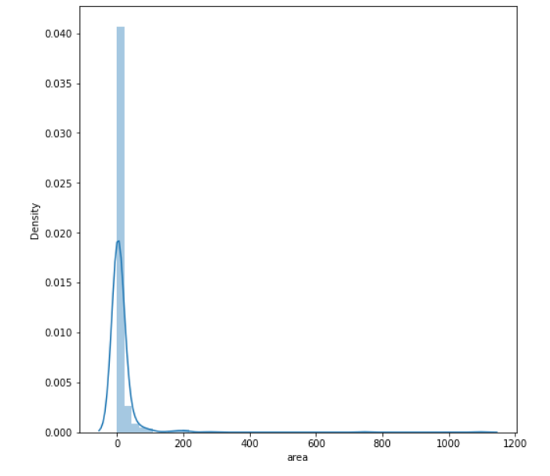

# RESULTS

**9.1 Sample Screens**

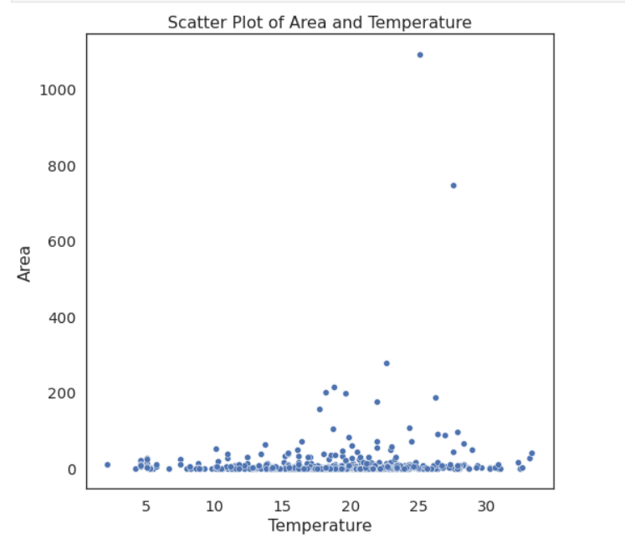

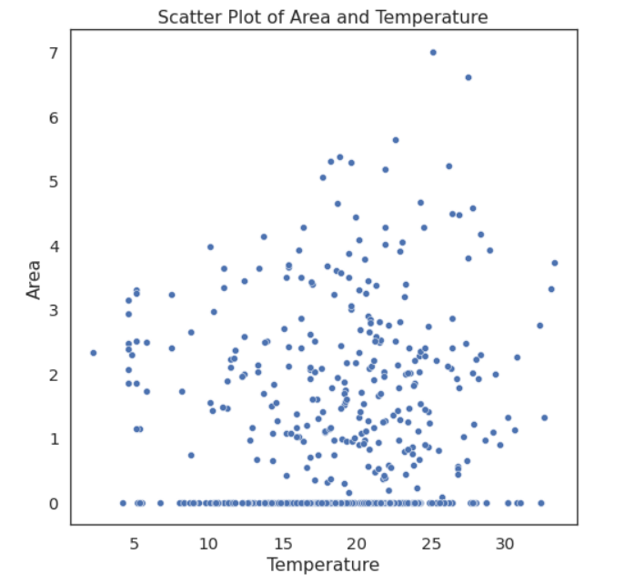

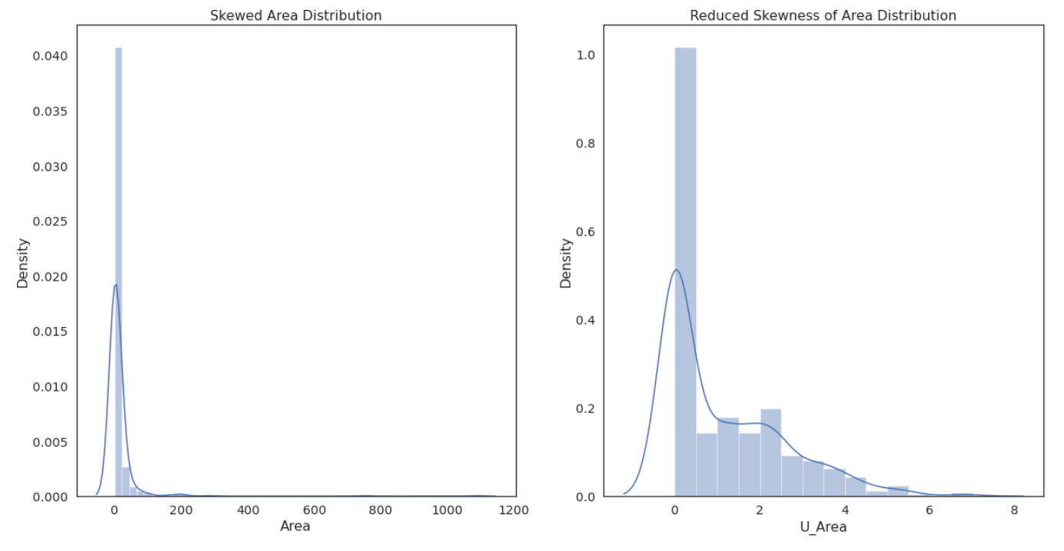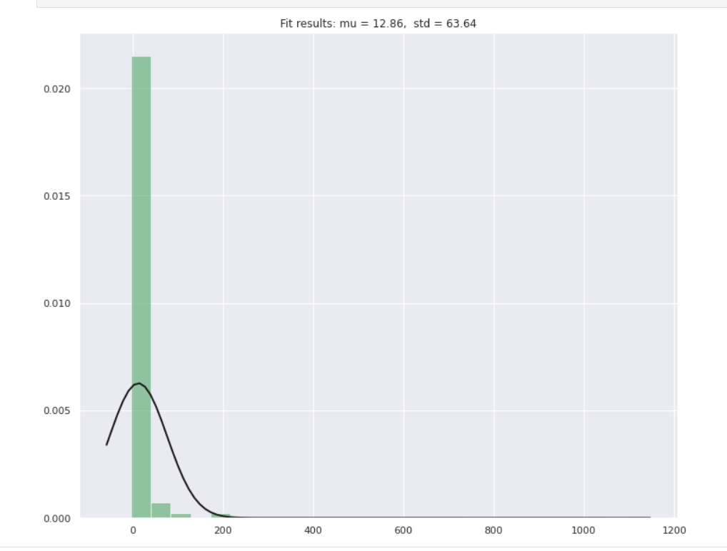

# ADVANTAGES AND DISADVANTAGES

## Advantages

* + 1. **Forest fires promote healthier trees**
    2. **Forest fires help to increase water availability**
    3. **Forest fires help to kill disease that can impact the biome**

## Disadvantages

* + 1. **Forest fires can create health problems for people**
    2. **Forest fires can trigger mudslides, landslides, and other forms of erosion.**
    3. **Forest fires can devastate the ecosystem**

**11. CONCLUSION**

A forest ﬁre risk prediction mecha-nism, based only on meteorological data and independent ofany weather prediction mechanism.The results demonstratesthe ability to predict forest ﬁre risk prediction with a low error on the number of ﬁres as well ason the predicted scale This seem like tough task but to the realization of the fact that fire fighters are not well equipped with the things they should be having as an AI researcher I am suggesting the way AI can help in this process. Though equipping the forest fire department with right gadget shall be much cheaper option.

# FUTURE WORKS

The development and direction of fire fighting works are moving toward 3S technology, which relies on digitizing forestry data, integrating forest fire warning, and monitoring system applications, and building automated, intelligent, and networked digital forest fire management systems

# REFERENCES

1. László F, Rajmund K, “Characteristics of forest fires and their impact on the environment”, Academic and Applied Research in Military and Public Management Science, vol.15, pp.5-17, 2016
2. Barker T, “The economics of avoiding dangerous climate change. An editorial essay on The Stern Review”, Climatic Change, vol. 89, pp. 173-194, 2008.
3. Mote T, Singh A, Prasad M, Kalwar P, “Predicting burned areas of forest fires: an artificial intelligence approach”, International Journal of Technical
4. Research and Applications, vol. 43, pp. 56-58, 2017. Lin Z, Liu HH, Wotton M, “Kalman filter-based large-scale wildfire monitoring with a system of UAVs”, IEEE Transactions on Industrial Electronics, vol. 66, pp. 606-615, 2018.
5. 5- Agarwal S, “Data mining: data mining concepts and techniques”, In International Conference on Machine Intelligence and Research Advancement, IEEE, 2013.